**JONAFARM MARKET SYSTEM**

**Final System Documentation**

**Student Name:**

**VALENTINE MBINYA MUTUNGA - SCT121-0512/2024**

**PAULINE MUTHONI WAWERU - SCT121-0511/2024**

**Course Name: Diploma of Information Technology**

**Unit Code:0421**

**Institution: Jomo Kenyatta University Of Agriculture and Technology**

**Lecturer:Dennis Kaburu**

**Date:18/02/2026**

# ABSTRACT

The Jonafarm Market System is a web-based platform developed to connect farmers, buyers, distributors, and administrators in one centralized digital marketplace. The system was created to address common agricultural marketing challenges such as exploitation by middlemen, lack of price transparency, delayed payments, and inefficient delivery processes.

The platform allows farmers to register and list produce, buyers to place orders, distributors to manage deliveries, and administrators to monitor transactions and generate reports. By integrating all stakeholders into one system, Jonafarm improves efficiency, accountability, and communication within the agricultural supply chain.

The system demonstrates how information technology can be used to enhance agribusiness operations and promote fair trade practices.

Contents

ABSTRACT 2

INTRODUCTION 4

1.1 Problem Statement 4

1.2 Objectives 4

2. SCOPE OF THE SYSTEM 5

3. SYSTEM OVERVIEW 5

3.1 User Roles 5

3.2 System Modules 6

4. SYSTEM DESIGN 6

4.1 Use Case Diagram 6

4.2 Class Diagram 8

4.3 Sequence Diagram 8

4.4 Activity Diagram 9

4.5 Component Diagram 11

4.6 Deployment Diagram 11

5. CONCLUSION 12

6. FUTURE IMPROVEMENTS 12

7. REFERENCES 13

8. SYSTEM IMPLEMENTATION 14

8.1 Technologies Used 14

8.2 System Modules Implemented 14

8.3 Database Design 15

Database Tables (JSON Files) 15

8.4 System Screenshots 15

8.4.1 Buyer sign-up page 16

8.4.2 Buyer Login page 16

8.4.3 Buyers Dashboard 17

8.4.4 Farmer Login Page 19

8.4.5 Farmers Dashboard 19

8.4.6 Admin login page 21

8.4.7 Admin Dashboard 21

8.4.8 Distributor Login Page 22

8.4.9 Distributors Dashboard 23

8.5 System Testing 23

8.6 Challenges Faced 24

8.7 Achievements 24

# INTRODUCTION

Agriculture plays a major role in economic development and food security. However, many small-scale farmers face difficulties in accessing reliable markets for their produce. Most farmers depend on middlemen who often dictate unfair prices and delay payments. Buyers also struggle to directly connect with farmers, leading to inefficiencies in the supply chain.

The Jonafarm Market System was developed to provide a digital solution that connects farmers, buyers, distributors, and administrators through a centralized online platform. The system enhances transparency, efficiency, and accountability in agricultural trade.

## 1.1 Problem Statement

Farmers face several challenges in agricultural marketing, including:

* Limited access to direct buyers
* Exploitation by middlemen
* Lack of price transparency
* Delayed payments
* Poor coordination in delivery and distribution

There is a need for a centralized digital platform that allows farmers to sell directly, buyers to order easily, distributors to manage deliveries, and administrators to oversee operations effectively.

## 1.2 Objectives

**Main Objective**

To develop a web-based market system that connects farmers, buyers, distributors, and administrators on one digital platform.

**Specific Objectives**

* To enable farmers to register and list their agricultural produce
* To allow buyers to browse products and place orders
* To enable distributors to manage and update delivery status
* To provide administrators with tools to monitor transactions and generate reports
* To improve transparency and efficiency in agricultural trade

# 2. SCOPE OF THE SYSTEM

The Jonafarm Market System focuses on managing the local agricultural supply chain through a centralized web platform. The system includes:

* User registration and authentication
* Produce listing and management
* Order placement and tracking
* Distributor assignment and delivery updates
* Payment and commission tracking
* Administrative reporting

**Limitations**

* The system does not support international trade
* Online mobile money integration is not automated in the current version
* The system is web-based and does not yet have a mobile application

# 3. SYSTEM OVERVIEW

The Jonafarm Market System is designed to integrate all stakeholders in the agricultural supply chain into one centralized web platform. The system ensures smooth interaction between users and efficient management of data and transactions.

## 3.1 User Roles

The system consists of four main users:

**1. Administrator**

* Manages user accounts
* Monitors orders and deliveries
* Generates reports
* Oversees system operations

**2. Farmer**

* Registers into the system
* Adds and manages produce listings
* Views incoming orders
* Tracks sales

**3. Buyer**

* Browses available produce
* Places orders
* Tracks order status

**4. Distributor**

* Views assigned deliveries
* Updates delivery status (Pending, In Transit, Delivered)
* Confirms completed deliveries

## 3.2 System Modules

The system is divided into the following modules:

* **Authentication Module** – Handles login and registration
* **Product Management Module** – Manages produce listings
* **Order Management Module** – Processes and tracks orders
* **Distributor Dashboard Module** – Manages deliveries
* **Payment & Commission Module** – Tracks payments
* **Reporting Module** – Generates sales and performance reports

# 4. SYSTEM DESIGN

The system design explains how the Jonafarm Market System is structured and how different components interact to achieve system functionality.

## 4.1 Use Case Diagram

The Use Case Diagram illustrates the interactions between the system and its main actors: Administrator, Farmer, Buyer, and Distributor. It shows key functions such as login, add produce, place order, assign distributor, update delivery status, and generate reports.

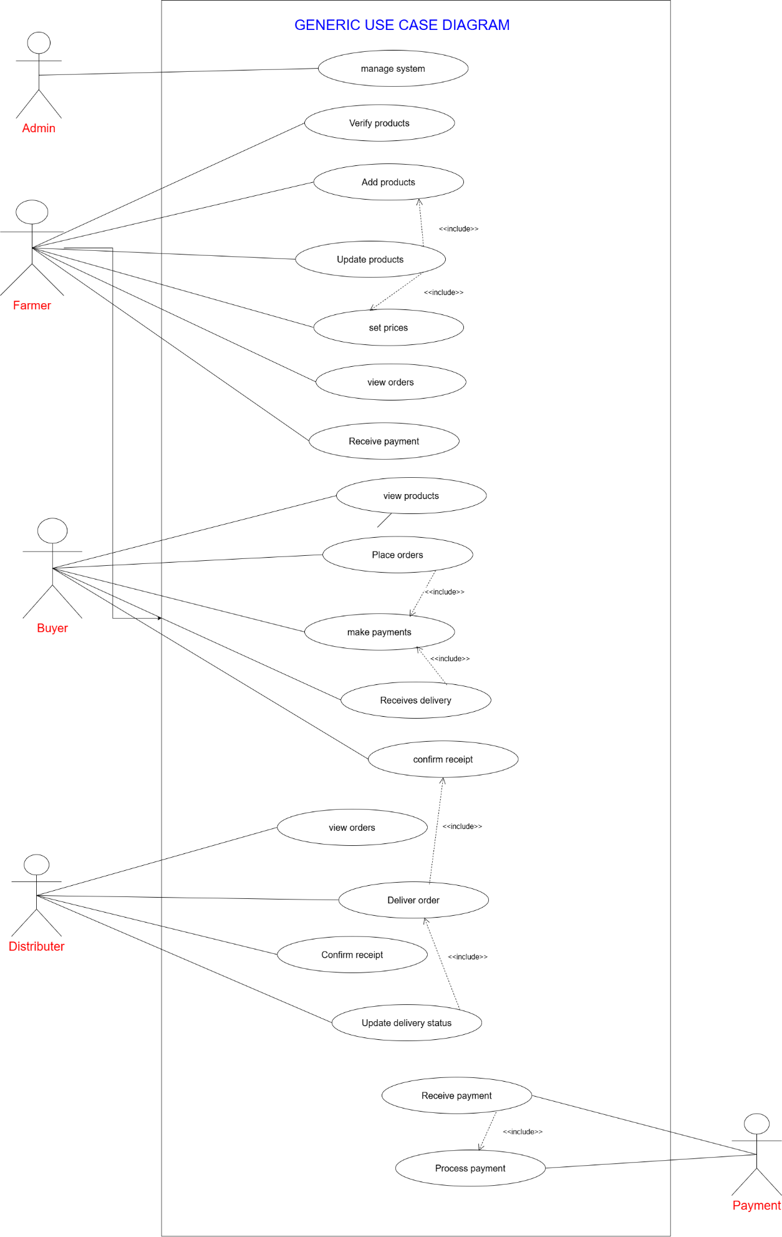

## 4.2 Class Diagram

The Class Diagram represents the structure of the system by showing the main classes, their attributes, methods, and relationships. Key classes include User, Farmer, Buyer, Distributor, Product, Order, Payment, and Delivery.

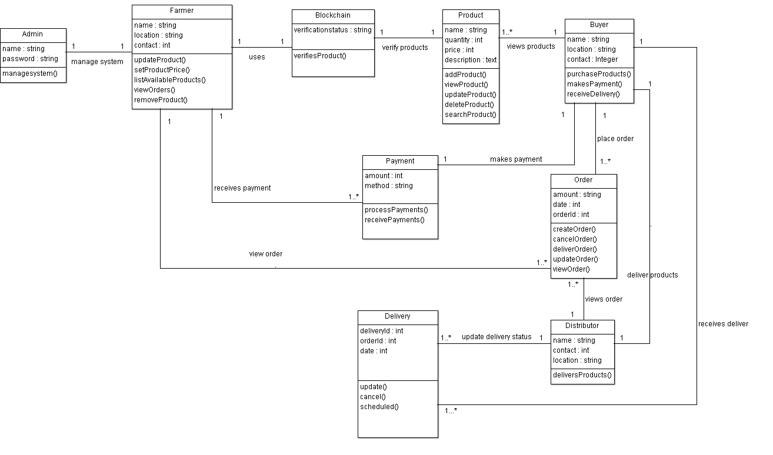

## 4.3 Sequence Diagram

The Sequence Diagram shows the step-by-step interaction between system components over time. For example, it explains how an order request moves from the user interface to the backend and database, then returns a response.

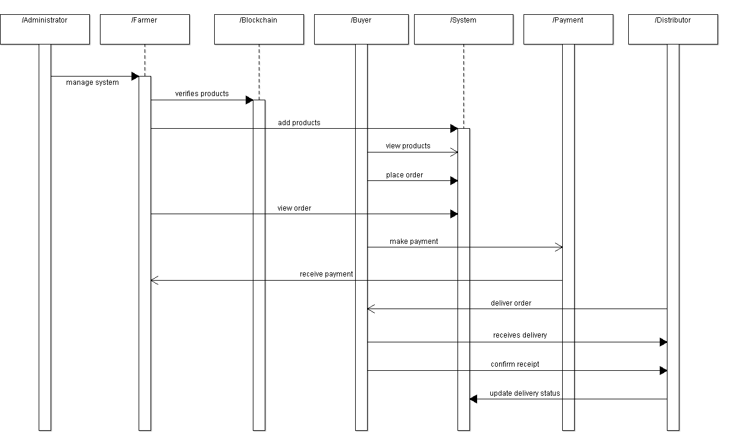

## 4.4 Activity Diagram

The Activity Diagram represents the workflow of system processes such as order placement. It shows actions, decision points, and the flow from start to end.

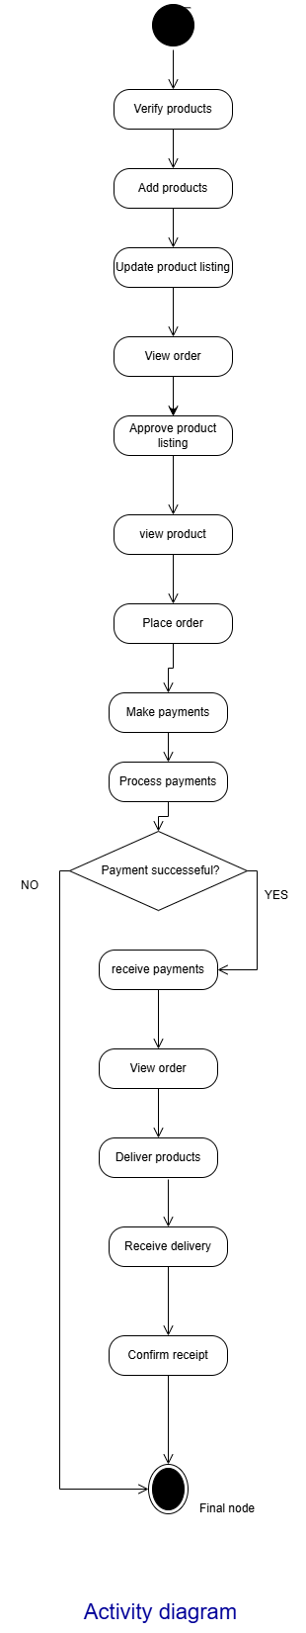

## 4.5 Component Diagram

The Component Diagram shows the major system components such as the User Interface, Application Server, Database, and Authentication Module, and how they interact.

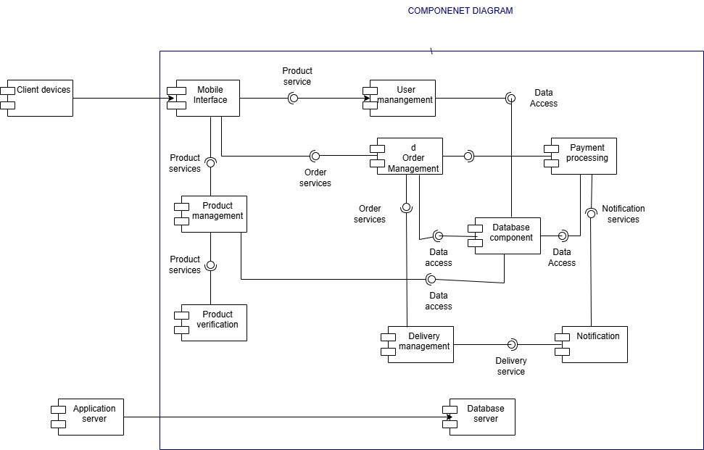

## 4.6 Deployment Diagram

The Deployment Diagram illustrates the physical architecture of the system, including client devices, web server, and database server.

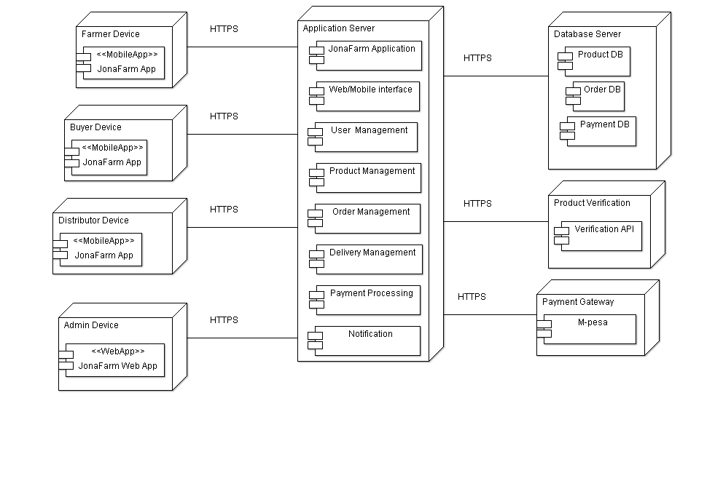

# 5. CONCLUSION

The Jonafarm Market System successfully provides a digital solution to challenges faced in agricultural marketing. By connecting farmers, buyers, distributors, and administrators on one centralized platform, the system improves transparency, efficiency, and coordination in the supply chain.

The implementation of this system demonstrates how web-based technologies can enhance agribusiness operations and reduce dependency on middlemen. Overall, the project achieved its intended objectives and provides a strong foundation for future improvements.

# 6. FUTURE IMPROVEMENTS

Although the system functions effectively, several enhancements can be made:

* Development of a mobile application version
* Integration of automated mobile money payments
* SMS and email notifications
* GPS-based delivery tracking
* Advanced analytics and performance dashboards

# 7. REFERENCES

* PHP Official Documentation
* MySQL Official Documentation
* HTML, CSS, and JavaScript Web Development Tutorials
* Software Engineering Course Notes

# 8. SYSTEM IMPLEMENTATION

This section describes how the Jonafarm Market System was developed, the technologies used, the system modules implemented, and how the system was tested. It provides practical evidence that the system was successfully built and is functional.

**STEP 2: TECHNOLOGIES USED**

## 8.1 Technologies Used

The system was developed using the following technologies:

* **Frontend:** HTML, CSS, JavaScript
* **Backend:** PHP
* **Database:**JSON FILES
* **Server Environment:** XAMPP
* **Development Tool:** Visual Studio Code
* **Browser for Testing:** Google Chrome

**STEP 3: MODULES IMPLEMENTED**

## 8.2 System Modules Implemented

The following modules were successfully implemented in the Jonafarm Market System:

1. **Authentication Module**

* User registration
* Login and logout functionality
* Role-based access (Admin, Farmer, Buyer, Distributor)

1. **Farmer Module**

* Add produce
* Edit and delete produce
* View received orders

1. **Buyer Module**

* Browse available products
* Place orders
* View order status

1. **Distributor Module**

* View assigned deliveries
* Update delivery status (Pending, In Transit, Delivered)

1. **Admin Module**

* Manage users
* Assign distributors
* Monitor orders
* Generate system reports

**STEP 4: DATABASE DESIGN & TABLES**

## 8.3 Database Design

The **JonaFarm Cloud-Based Market System** uses a **file-based JSON database** instead of MySQL.  
Each JSON file represents a table, and relationships between users, farmers, buyers, distributors, products, orders, and deliveries are maintained using **unique IDs (Primary Keys)** and **references (Foreign Keys)**.

This approach:

Reduces data duplication

Maintains data integrity

Makes the system lightweight and easy to deploy

Supports CRUD operations (Create, Read, Update, Delete)

## Database Tables (JSON Files)

| **Table Name** | **Purpose** |
| --- | --- |
| users.json | Stores all system users and roles |
| farmers.json | Stores farmer profiles |
| distributors.json | Stores distributor details |
| products.json | Stores all farm produce |
| orders.json | Stores customer orders |

## 8.4 System Screenshots

This section provides visual evidence that the Jonafarm Market System was successfully implemented and is functional.

This improves **security, clarity, and user experience**, because each user only sees features related to their role.

### 8.4.1 Buyer sign-up page

Allows new buyers to:

Create an account

Enter name, email, and password

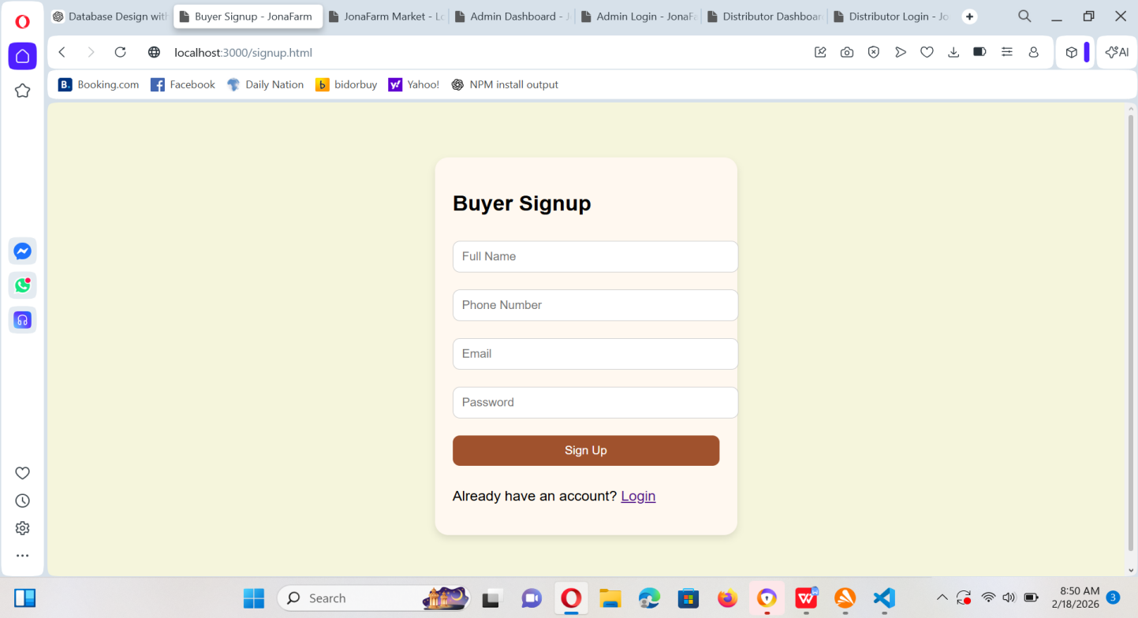

### 8.4.2 Buyer Login page

Allows buyers to:

Login using their credentials

Be redirected to the Buyer Dashboard

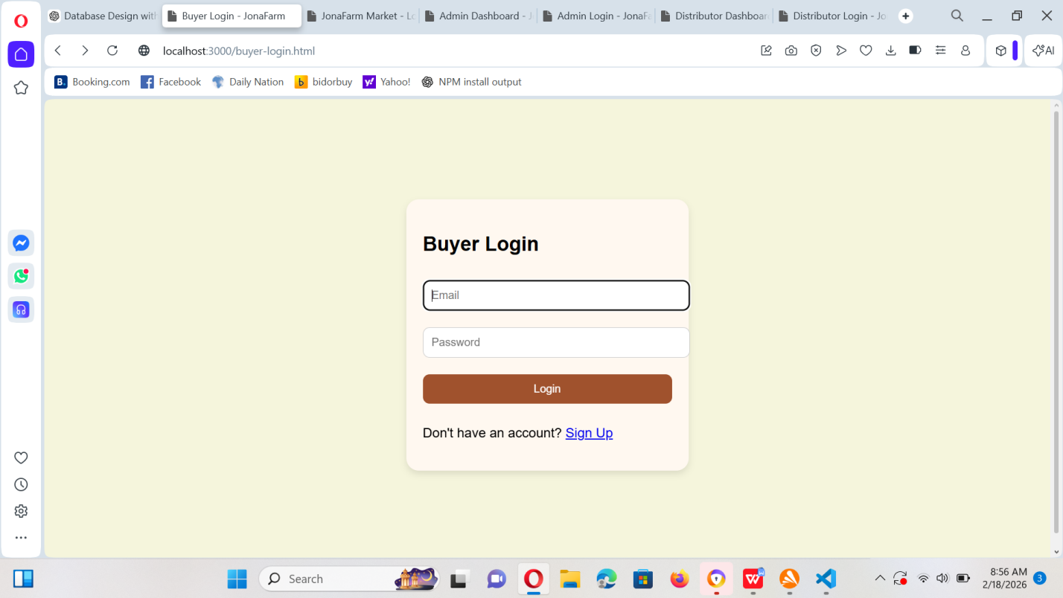

### 8.4.3 Buyers Dashboard

Allows buyers to:

View available products

See verified products

Place orders

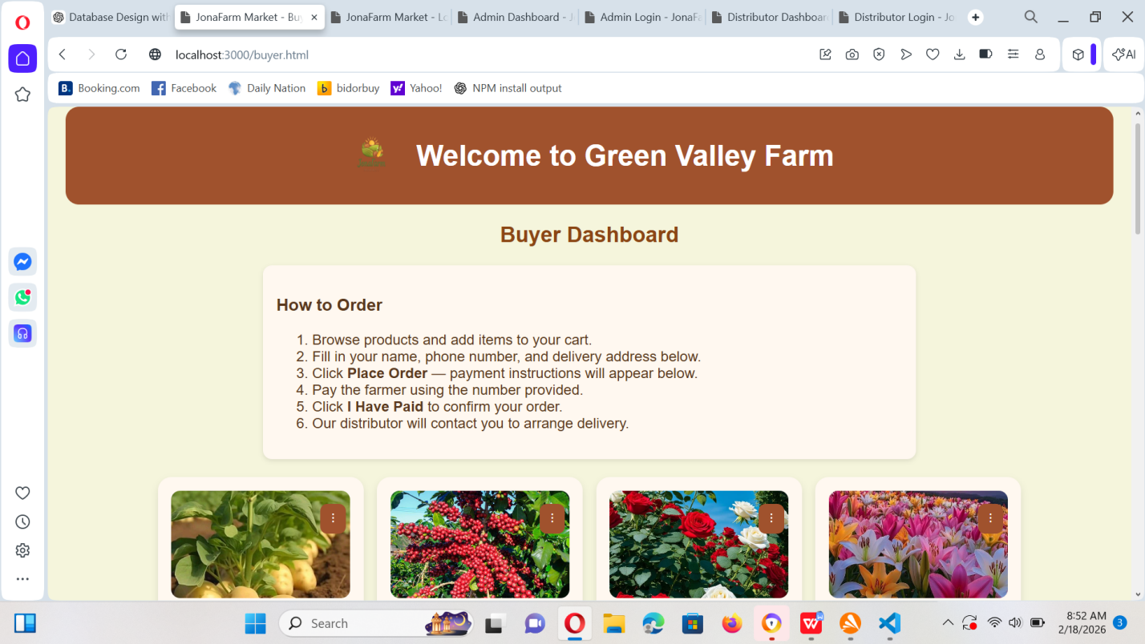

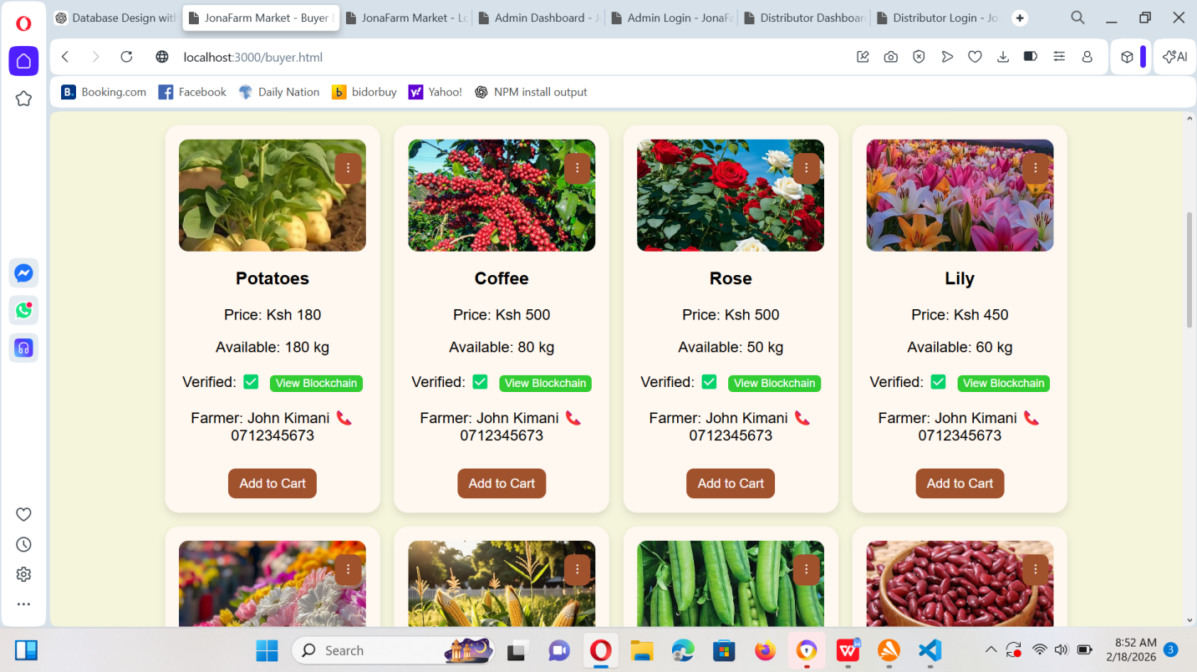

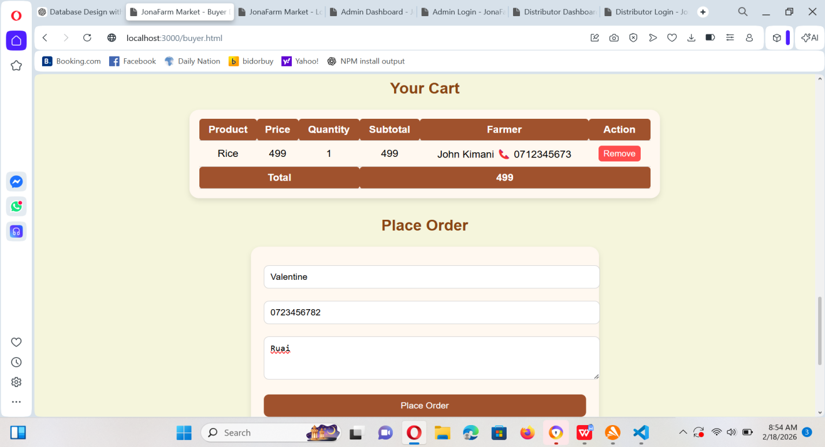

### 8.4.4 Farmer Login Page

Allows farmers to:

Login to their account

Access their dashboard

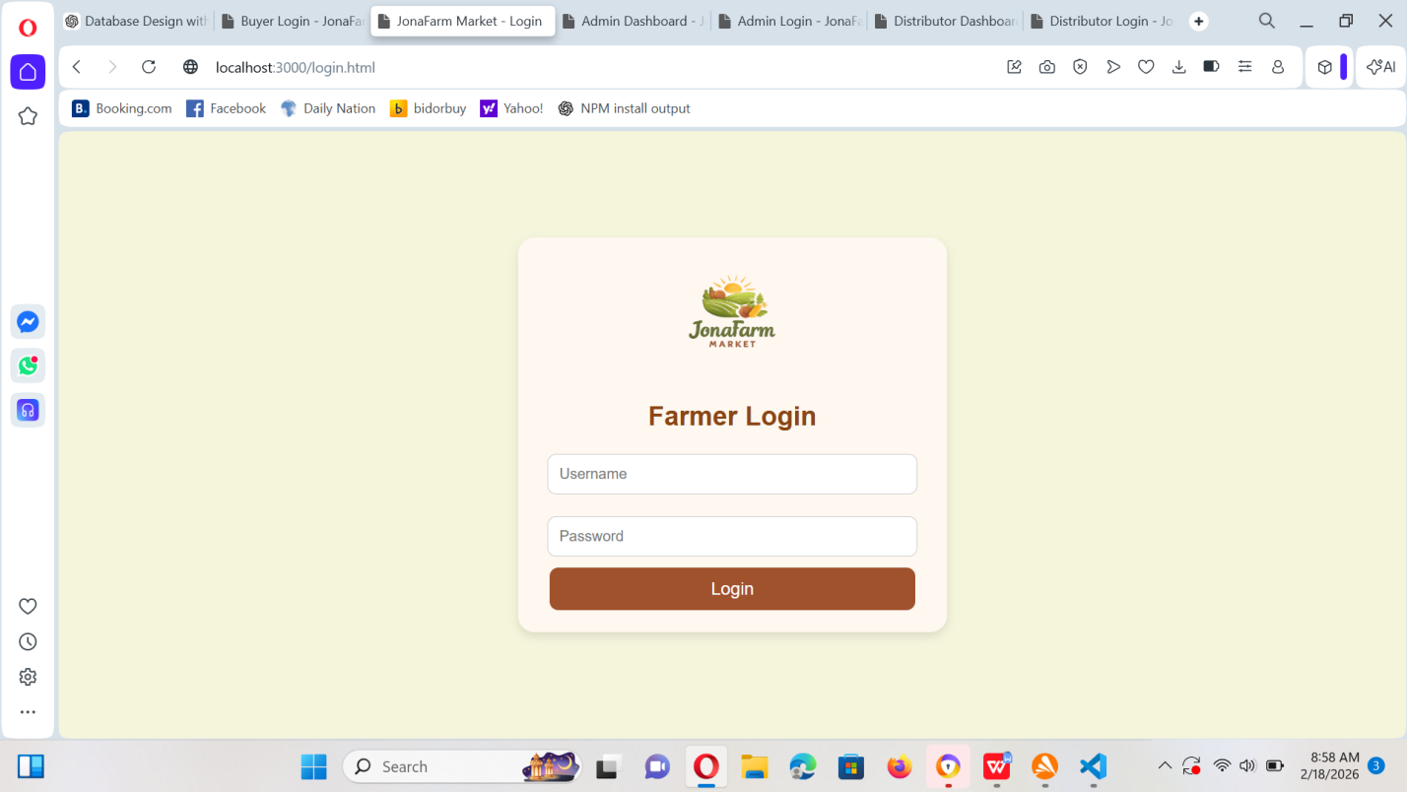

### 8.4.5 Farmers Dashboard

The farmer dashboard allows farmers to:

View all their listed products

See orders made by buyers

Track the status of each order

View blockchain verification records for their products

Confirm that their products are marked as verified and trusted

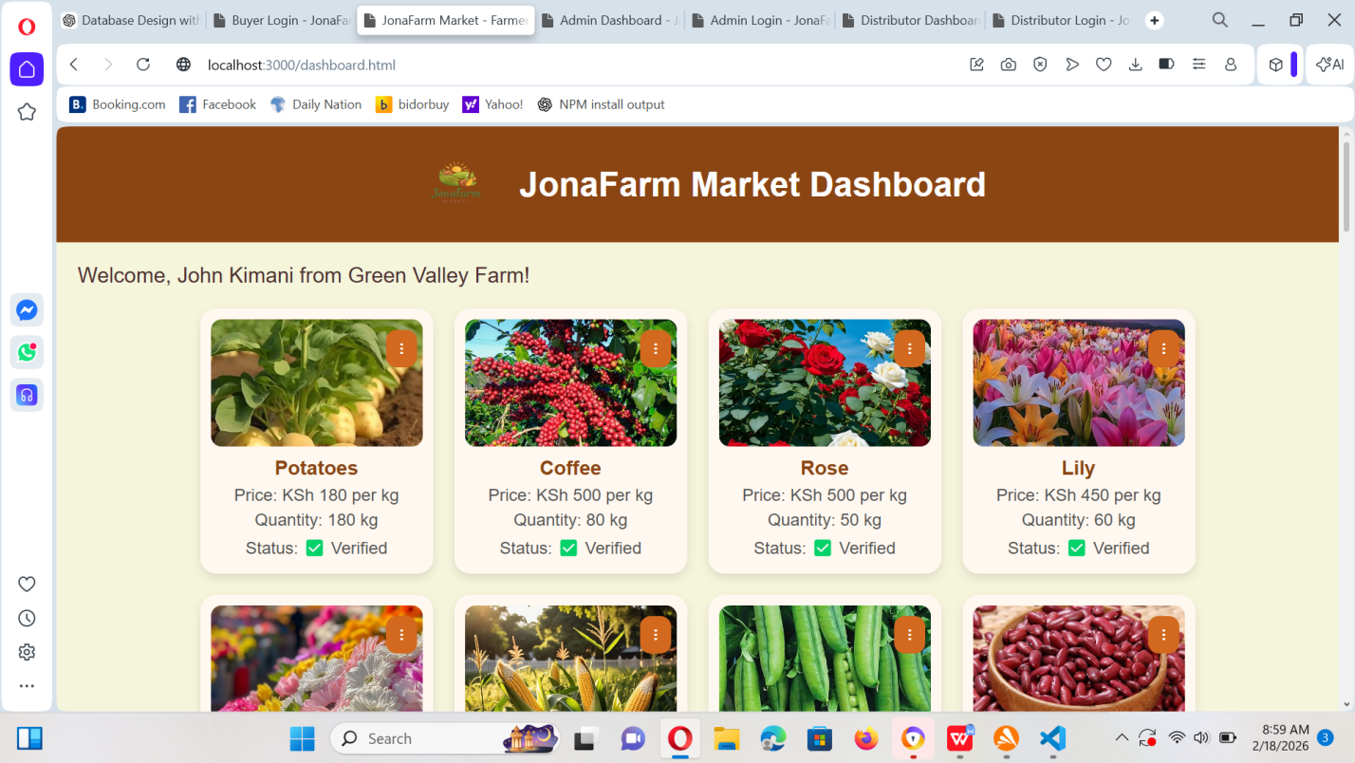

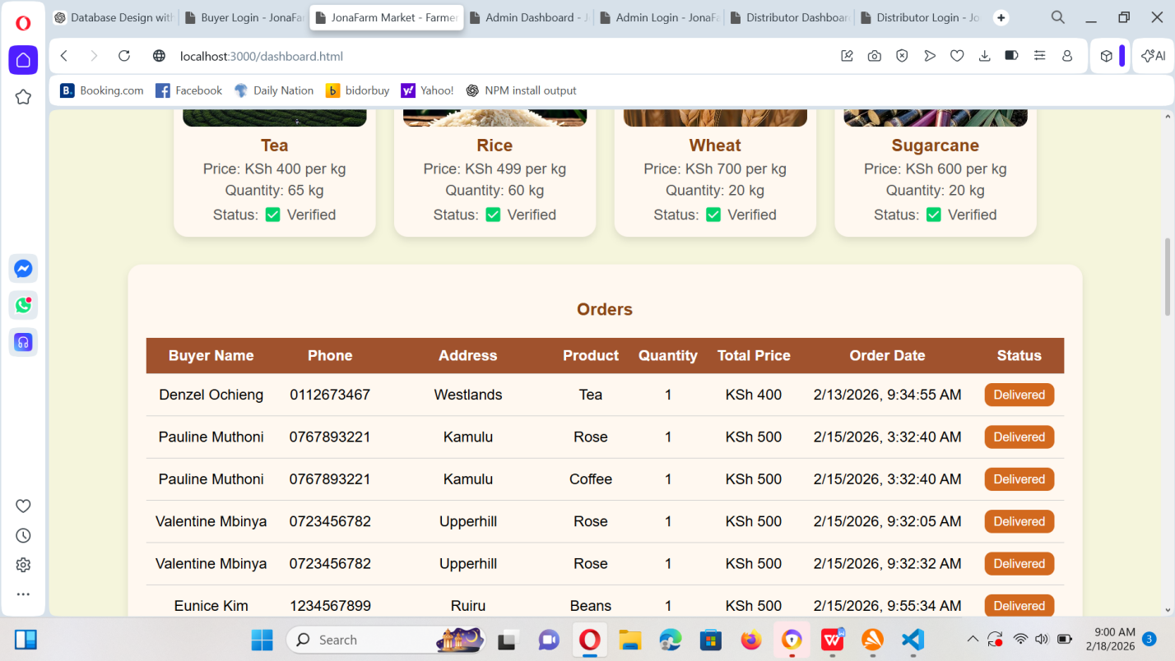

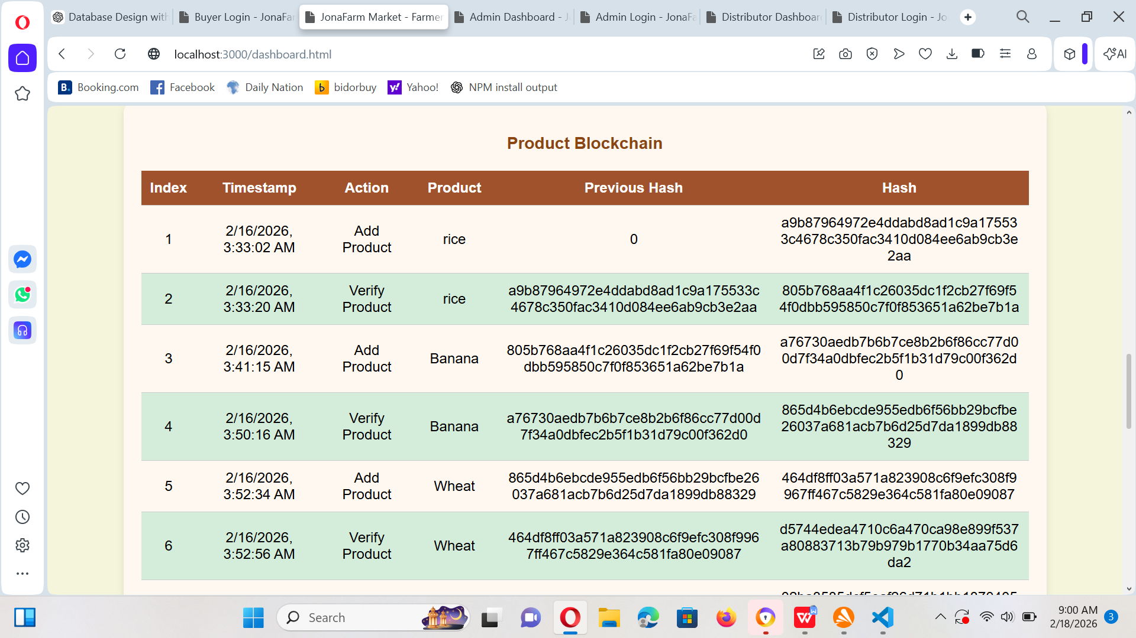

### 8.4.6 Admin login page

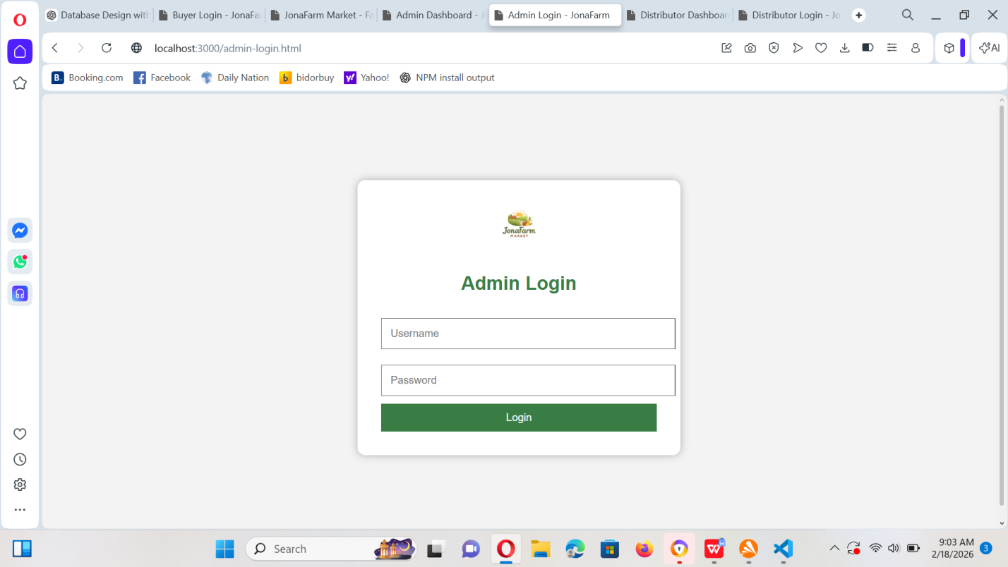

### 8.4.7 Admin Dashboard

The admin dashboard allows the administrator to:

Add new products into the system

Update existing product details

Delete products that are no longer available

Verify products using the blockchain verification system

View all orders placed by buyers

Generate system reports for monitoring and decision making

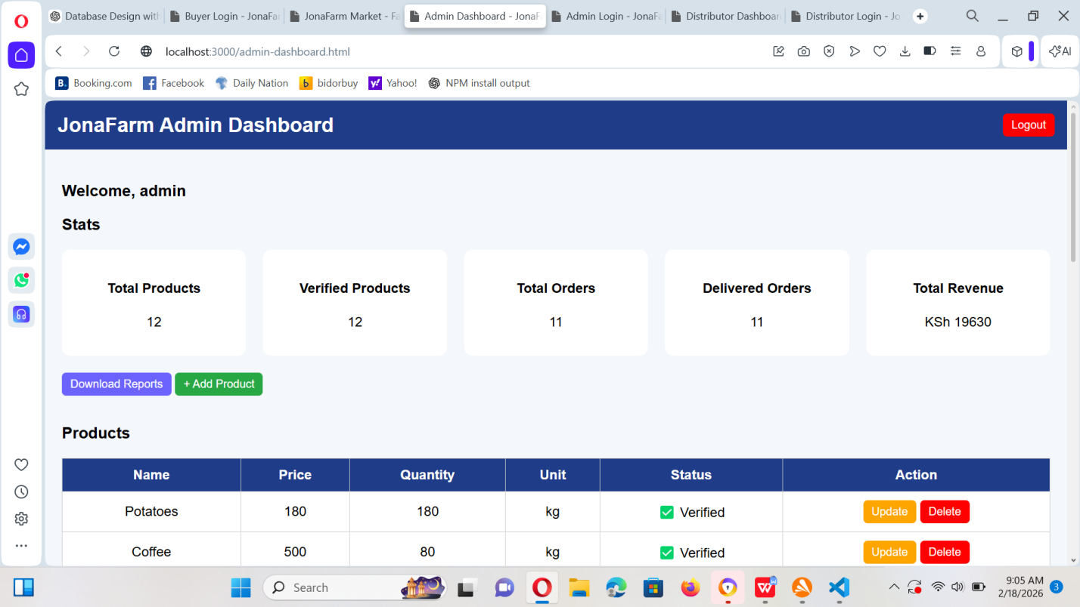

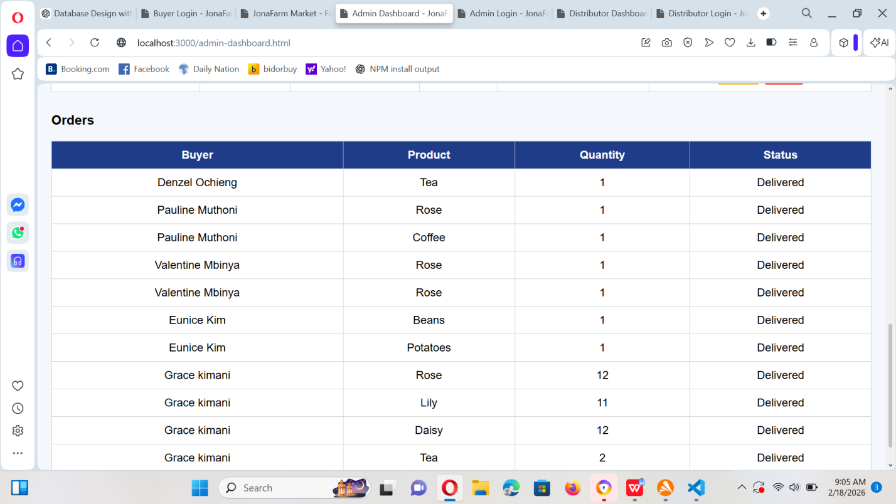

### 8.4.8 Distributor Login Page

Allows distributors to:

Login securely

Access their dashboard

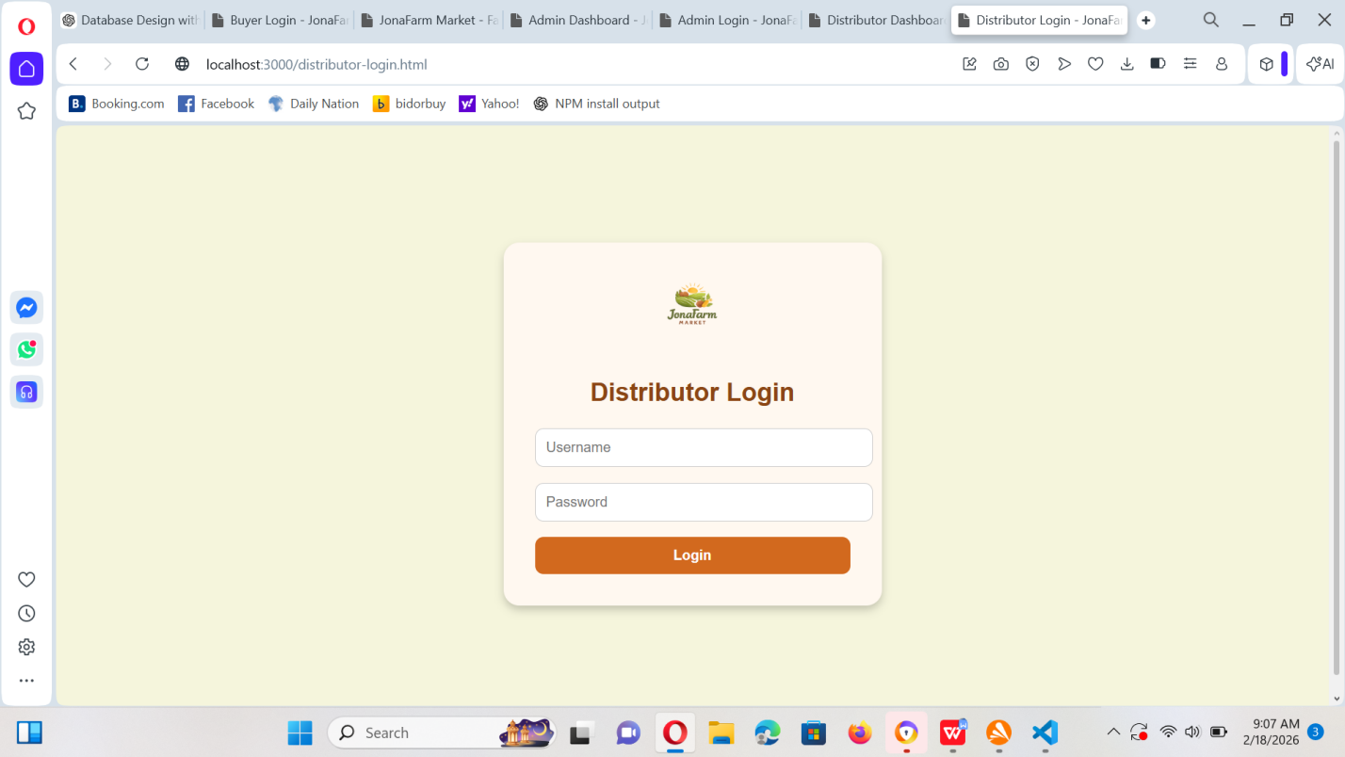

### 8.4.9 Distributors Dashboard

Allows distributors to:

View assigned orders

Update delivery status

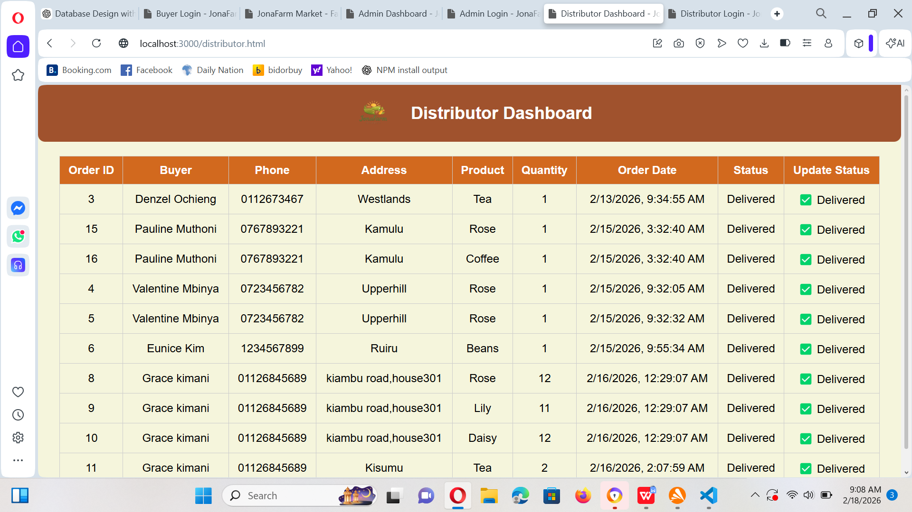

## 8.5 System Testing

The system was tested to ensure that all modules function correctly. The following tests were performed:

* Login and registration testing for all user roles
* Product addition and modification testing
* Order placement and tracking testing
* Distributor assignment and delivery status updates
* Report generation testing

All modules operated as expected, and errors encountered during testing were corrected.

## 8.6 Challenges Faced

During system development, several challenges were encountered:

* Database relationship errors
* Session management issues
* Role-based access control implementation
* Debugging backend logic errors

These challenges were resolved through testing, code review, and troubleshooting.

## 8.7 Achievements

* Successful development of a fully functional web-based market system
* Implementation of role-based dashboards
* Proper database design with relational integrity
* Integration of order and delivery tracking features
* Implemented block-chain based product to ensure trusted and tamper proof product records
* Enabled a secure authentication and access control for all user roles